**PIZZA SALES SQL QUERIES**

**A.KPI’S**

1. TOTAL REVENUE:

SELECT SUM(total_price) AS Total_Revenue from pizza_sales

C:\Users\home\Pictures\Screenshots\Screenshot (12).png

2. Average order value

SELECT SUM(total_price) / COUNT(DISTINCT order_id) AS Avg_order_value from pizza_sales;

C:\Users\home\Pictures\Screenshots\Screenshot (11).png

3. Total Pizza Sold

select sum(quantity) as Total_Pizza_Sold from pizza_sales

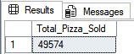

4. Total Orders

select count(distinct order_id)as Total_Orders from pizza_sales

C:\Users\home\Pictures\Screenshots\Screenshot (14).png

5. Average Pizza Per Order

select cast(cast(sum(quantity) as decimal(10,2)) /

cast(count(distinct order_id)as decimal(10,2)) as decimal(10,2)) as Avg_Pizza_Per_Order from pizza_sales

C:\Users\home\Pictures\Screenshots\Screenshot (16).png

6. Total Orders

SELECT DATENAME(DW,order_date)as order_day, COUNT(DISTINCT order_id)as Total_orders

from pizza_sales

GROUP BY DATENAME(DW,order_date)

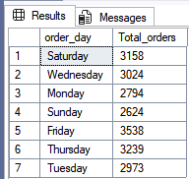

7.Hourly Trend For Total Orders

SELECT DATENAME(MONTH, order_date)as month_name, COUNT(DISTINCT order_id)as Total_Orders

FROM pizza_sales GROUP BY DATENAME(MONTH,order_date)

order by Total_Orders DESC

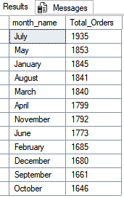

8. Percentage of Sales by Pizza Category

SELECT pizza_category, SUM(total_price) * 100 / (SELECT SUM(total_price)FROM pizza_sales) AS Total_Sales FROM pizza_sales

WHERE MONTH(order_date)=1

GROUP BY pizza_category

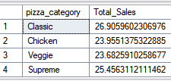

9. Total Pizza Sold by Pizza Category

SELECT pizza_size, CAST(SUM(total_price) AS DECIMAL(10,2)) AS Total_Sales, CAST(SUM(total_price)*100 / (SELECT SUM(total_price) FROM pizza_sales) AS DECIMAL(10,2)) AS PCT

FROM pizza_sales

WHERE DATEPART(quarter, order_date)=1

GROUP BY pizza_size

ORDER BY PCT DESC

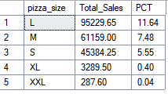

10. Top 5 Best Sellers by Revenue ,Total Quantity and Total Orders

SELECT TOP 5 pizza_name, SUM(total_price) AS Total_Revenue FROM pizza_sales

GROUP BY pizza_name

ORDER BY Total_Revenue DESC

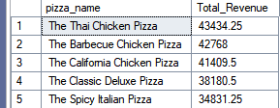

11. Bottom 5 Pizzas by Revenue

SELECT TOP 5 pizza_name, SUM(total_price) AS Total_Revenue FROM pizza_sales

GROUP BY pizza_name

ORDER BY Total_Revenue asc

